Oracle Administration Services

ORACLE_Statspack Creation

Submitted to



By



CIS, Wipro Limited

Document Details

Project Name | Innogy SE
Account | CIS
IT Component/Application Title | Oracle statspack creation
Current Version | 1.5
List of Contributors | Chetan Patel,Saurabh Nigam,JitenKumar Pansara ,Sreya Puthukudy
Customer Contact Information

Version History
(All revisions made to this document must be listed in chronological order. All revisions must be approved. Review and Approval can be done by an internal source or by the customer)
Version | Date of Revision | Description | Author | Reviewed By | Approved By
1.0 | 06-04-2015 | Intial Draft | Chetan Patel | Chetan Patel | Mihir Gajjar
1.1 | 06-06-2016 | Document Completed | Chetan Patel | Saurabh Nigam | Mihir Gajjar
1.2 | 06-06-2016 | Updated document to standard format | JitenKumar Pansara | JitenKumar pansara | Mahesh Keshatwar
1.3 | 17-05-2017 | Wipro and Innogy Logo changed | Sreya Puthukudy | JitenKumar pansara | Mahesh Keshatwar
1.4 | 31-11-2017 | Updated document to Wipro Standard format with header and footer | Sreya Puthukudy | JitenKumar pansara | Yogesh Desai
1.5 | 05-01-2019 | Updated the content | Sreya Puthukudy | JitenKumar pansara | Santosh Badiger

Document Distribution List
S.No | Name and Company | Purpose
1 | RWEIT-ORACLEDBA | This document is regarding oracle statspack creation
2

TABLE OF CONTENTS
1. Purpose 5
2. Scope 5
3. Statspack Database Space Requirement 5
4. General Information And Recomondation 5
5. Overview 6
6. Architecture 6
7. Installing The Statspack Package 8
8. Creating Workload Statistics 14
8.1 Creating Workload Statistics Manually 14
8.2 Creating Workload Statistics Automatically 15
9. Utilizing Statspack Report To Understand Db Behavior. 17
10. Purging Workload Statistics 19
11. Reference 20

Purpose
This document is prepared for configuring and installing information about
the StatsPack package in Oracle database at RWE GBS UK.

Scope
This document is prepared for RWE GBS UK Wipro sustenance team and provides the concepts of Oracle Statspack at RWE GBS UK This note is applicable for Oracle RDBMS releases 9 and greater, and is related to the task of gathering database and session level performance

Statspack Database Space Requirement
- Oracle does not recommend installing the package in the SYSTEM tablespace. A more appropriate tablespace (if it exists) would be a "TOOLS" tablespace. Best practice is to create a tablespace for perfstat user. Default Tablespace space of 500 MB in place dedicated to Perfstat Schema

The amount of database space required by the package will vary considerably based on the frequency of snapshots, the size of the database and instance, and

the amount of data collected (which is configurable). It is therefore difficult to provide general storage clauses and space utilization predictions which will be accurate at each site.

General Information And Recomondation
- During the installation process, the user PERFSTAT will be created, default password PERFSTAT.
- The installation SQL script will prompt for the PERFSTAT user's default and Oracle temporary tablespaces and also for the tablespace in which the tables and indexes will be created

NOTE
Do not specify the SYSTEM tablespace for the PERFSTAT users DEFAULT or TEMPORARY tablespaces; if SYSTEM is specified the installation will abort with an error indicating this is the problem. This is enforced as Oracle does not recommend using the SYSTEM tablespace to store statistics data, nor for sorting. Oracle use a TOOLS tablespace to store the data,

Overview
STATSPACK is a performance diagnosis tool, available since Oracle8i. STATSPACK is a diagnosis tool for instance-wide performance problems; it also supports application tuning activities by providing data which identifies high-load SQL statements. STATSPACK can be used both proactively to monitor the changing load on a system, and also reactively to investigate a performance problem.

Architecture
To fully understand the STATSPACK architecture, we have to look at the basic nature of the STATSPACK utility.
When a snapshot is executed, the STATSPACK software will sample from the RAM in-memory structures inside the SGA and transfer the values into the corresponding STATSPACK tables. These values are then available for comparing with other snapshots.
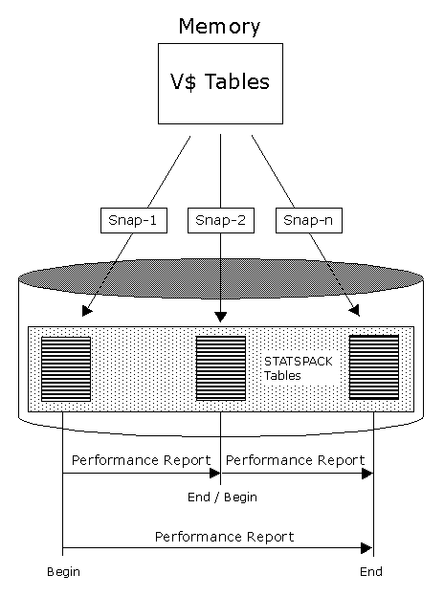
Note that in most cases, there is a direct correspondence between the v$ view in the SGA and the corresponding STATSPACK table. For example, we see that the stats$sysstat table is similar to the v$sysstat view.

SQL> desc v$sysstat;
Name Null? Type
----------------------------------------- -------- -----------------------
STATISTIC# NUMBER
NAME VARCHAR2(64)
CLASS NUMBER
VALUE NUMBER
STAT_ID NUMBER
SQL> desc stats$sysstat;
Name Null? Type
----------------------------------------- -------- -----------------------
SNAP_ID NOT NULL NUMBER
DBID NOT NULL NUMBER
INSTANCE_NUMBER NOT NULL NUMBER
STATISTIC# NOT NULL NUMBER
NAME NOT NULL VARCHAR2(64)
VALUE NUMBER
The information from the V$VIEWS collects database information at startup time and continues to add the values until the instance is shutdown. In order to get a meaningful elapsed-time report, you must run a STATSPACK report that compares two snapshots as shown above. It is critical to understand that a report will be invalid if the database is shut down between snapshots. This is because all of the accumulated values will be reset, causing the second snapshot to have smaller values than the first snapshot.

Installing The Statspack Package
Step 1: Go to cmd prompt Start → Run → cmd → Press Enter
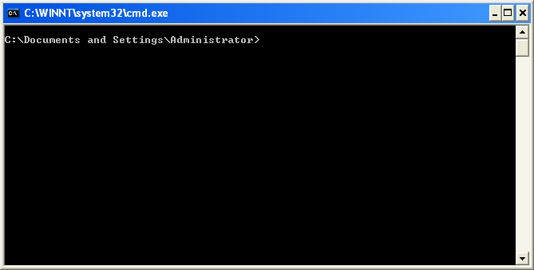
Step 2: Connect to the database as a sys user.
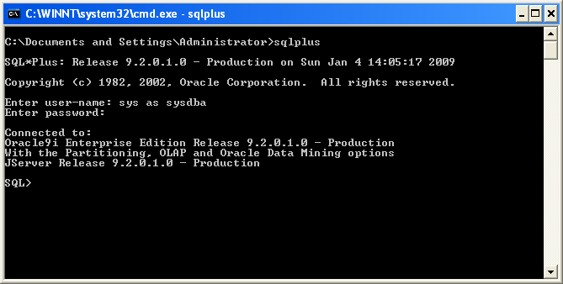

Step 3: Now create a tablespace for perfstat user with minimum 500mb of space.
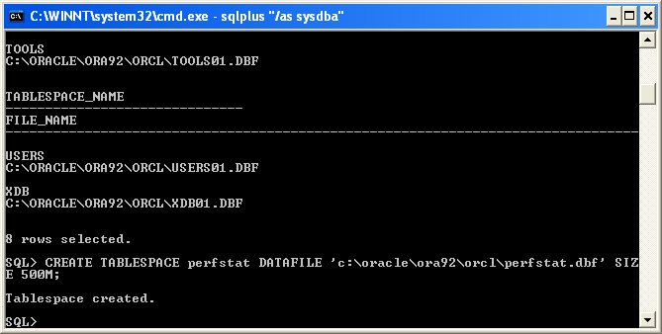

Step 4: Now run the spcreate.sql script. It’s located in C:\oracle\ora92\rdbms\admin\spcreate.sql. The path will depends on installation of Oracle software in the server.
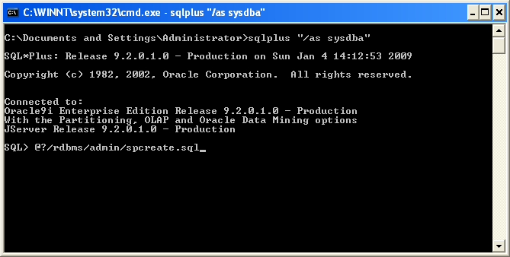
Step 5: Once the installation will start it will prompt for the below information.
- Perfstat user password
- Default tablespace for perfstat user (Do not specify system)
- Default temporary tablespace for perfstat user (Do not specify system)

SQL> @?/rdbms/admin/spcreate.sql
... Installing Required Packages

Package created.

Grant succeeded.

View created.

Package body created.

... ..........
.............

... Creating PERFSTAT user ...

Choose the PERFSTAT user's password.

Not specifying a password will result in the installation FAILING

Specify PERFSTAT password
Enter value for perfstat_password: perfstat
perfstat

PL/SQL procedure successfully completed.

User created.

Grant succeeded.

..........

..........

Below are the list of online tablespaces in this database.
Decide which tablespace you wish to create the STATSPACK tables
and indexes. This will also be the PERFSTAT user's default tablespace.

Specifying the SYSTEM tablespace will result in the installation
FAILING, as using SYSTEM for performance data is not supported.

TABLESPACE_NAME CONTENTS
------------------------------ ---------
DRSYS PERMANENT
EXAMPLE PERMANENT
INDX PERMANENT
PERFSTAT PERMANENT
TEMP TEMPORARY
TOOLS PERMANENT
UNDOTBS1 UNDO
USERS PERMANENT
XDB PERMANENT

9 rows selected.

Specify PERFSTAT user's default tablespace
Enter value for default_tablespace: perfstat
Using tools for the default tablespace

PL/SQL procedure successfully completed.

User altered.

User altered.

Choose the PERFSTAT user's temporary tablespace.

Specifying the SYSTEM tablespace will result in the installation
FAILING, as using SYSTEM for the temporary tablespace is not recommended.

Specify PERFSTAT user's temporary tablespace.
Enter value for temporary_tablespace: temp

Synonym created.

Table created.

............

............

NOTE:
SPCTAB complete. Please check spctab.lis for any errors.

SQL> -- Create the statistics Package
SQL> @@spcpkg
SQL> Rem
SQL> Rem $Header: spcpkg.sql 17-apr-2002.16:59:10 vbarrier Exp $
SQL> Rem
SQL> Rem spcpkg.sql
SQL> Rem
SQL> Rem Copyright (c) 1999, 2002, Oracle Corporation. All rights reserved.
SQL> Rem
SQL> Rem NAME
SQL> Rem spcpkg.sql
SQL> Rem
SQL> Rem DESCRIPTION
SQL> Rem SQL*PLUS command file to create statistics package
SQL> Rem
SQL> Rem NOTES
SQL> Rem Must be run as the STATSPACK owner, PERFSTAT
SQL> Rem
SQL> Rem MODIFIED (MM/DD/YY)
SQL> Rem vbarrier 03/20/02 - 2184504
SQL> Rem spommere 03/19/02 - 2274095
SQL> Rem vbarrier 03/05/02 - Segment Statistics
SQL> Rem spommere 02/14/02 - cleanup RAC stats that are no longer needed
SQL> Rem spommere 02/08/02 - 2212357
SQL> Rem cdialeri 02/07/02 - 2218573
SQL> Rem cdialeri 01/30/02 - 2184717
SQL> Rem cdialeri 01/09/02 - 9.2 - features 2
SQL> Rem cdialeri 11/30/01 - 9.2 - features 1
SQL> Rem hbergh 08/23/01 - 1940915: use substrb on sql_text
SQL> Rem cdialeri 04/26/01 - 9.0
SQL> Rem cdialeri 09/12/00 - sp_1404195
SQL> Rem cdialeri 04/07/00 - 1261813
SQL> Rem cdialeri 03/28/00 - sp_purge
SQL> Rem cdialeri 02/16/00 - 1191805
SQL> Rem cdialeri 11/01/99 - Enhance, 1059172
SQL> Rem cgervasi 06/16/98 - Remove references to wrqs
SQL> Rem cmlim 07/30/97 - Modified system events
SQL> Rem gwood.uk 02/30/94 - Modified
SQL> Rem densor.uk 03/31/93 - Modified
SQL> Rem cellis.uk 11/15/89 - Created
SQL> Rem
SQL>
SQL> set echo off;
Creating Package STATSPACK...

Package created.

No errors.
Creating Package Body STATSPACK...

Package body created.

No errors.

NOTE:
SPCPKG complete. Please check spcpkg.lis for any errors.

SQL>

Creating Workload Statistics
There are two ways you can take snapshot of database.
- Manually
- Automated

Creating workload statistics manually
Step 1: To fire a snapshot manually we have to logon to the Perfstat schema using the password

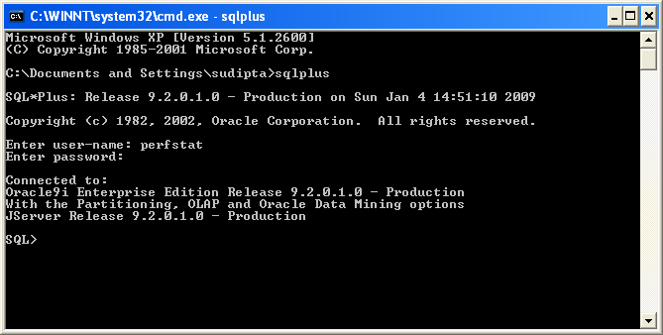

Step 2: fire the command

exec statspack.snapshot;

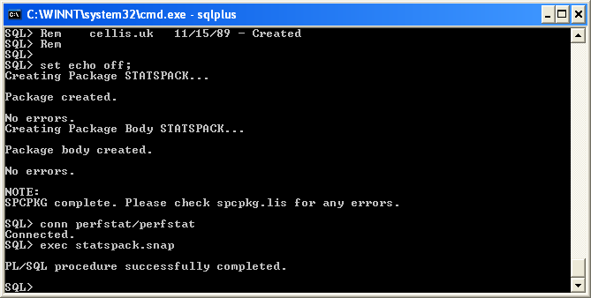

Creating workload statistics automatically
You can generate snap automatically by running the below script. By default the spauto.sql script schedule a snapshot every one hour, 24*7 hour on hour will snap of level 5.

$ORACLE_HOME/rdbms/admin/spauto.sql to achive the same.

SQL> @?/rdbms/admin/spauto.sql
SQL> Rem $Header: spauto.sql 16-feb-00.16:49:37 cdialeri Exp $
SQL> Rem spauto.sql
SQL> Rem Copyright (c) Oracle Corporation 1999, 2000. All Rights Reserved.
SQL> Rem NAME
SQL> Rem spauto.sql
SQL> Rem DESCRIPTION
SQL> Rem SQL*PLUS command file to automate the collection of STATPACK
SQL> Rem statistics.
SQL> Rem
SQL> Rem NOTES
SQL> Rem Should be run as the STATSPACK owner, PERFSTAT.
SQL> Rem Requires job_queue_processes init.ora parameter to be
SQL> Rem set to a number >0 before automatic statistics gathering
SQL> Rem will run.
SQL> Rem
SQL> Rem MODIFIED (MM/DD/YY)
SQL> Rem cdialeri 02/16/00 - 1191805
SQL> Rem cdialeri 12/06/99 - 1059172, 1103031
SQL> Rem cdialeri 08/13/99 - Created
SQL> Rem
SQL> spool spauto.lis
SQL> -- Schedule a snapshot to be run on this instance every hour, on the hour
SQL> variable jobno number;
SQL> variable instno number;
SQL> begin
2 select instance_number into :instno from v$instance;
3 dbms_job.submit(:jobno, 'statspack.snap;', trunc(sysdate+1/24,'HH'), 'tru
nc(SYSDATE+1/24,''HH'')', TRUE, :instno);
4 commit;
5 end;
6 /

PL/SQL procedure successfully completed.

SQL> prompt Job number for automated statistics collection for this instance

Job number for automated statistics collection for this instance
SQL> prompt ~~~~~~~~~~~~~~~~~~~~~~~~~~~~~~~~~~~~~~~~~~~~~~~~~~~~~~~~~~~~~~
SQL> prompt Note that this job number is needed when modifying or removing
Note that this job number is needed when modifying or removing
SQL> prompt the job:
the job:
SQL> print jobno

JOBNO
----------
1
SQL> prompt Job queue process
~~~~~~~~~~~~~~~~~
SQL> prompt Below is the current setting of the job_queue_processes init.ora

Below is the current setting of the job_queue_processes init.ora
SQL> prompt parameter - the value for this parameter must be greater
parameter - the value for this parameter must be greater
SQL> prompt than 0 to use automatic statistics gathering:
than 0 to use automatic statistics gathering:
SQL> show parameter job_queue_processes

NAME TYPE VALUE
------------------------------------ ----------- ------------------------------
job_queue_processes integer 10
SQL> prompt Next scheduled run
Next scheduled run
SQL> prompt ~~~~~~~~~~~~~~~~~~
~~~~~~~~~~~~~~~~~~
SQL> prompt The next scheduled run for this job is:
The next scheduled run for this job is:
SQL> select job, next_date, next_sec
2 from user_jobs
3 where job = :jobno;

JOB NEXT_DATE NEXT_SEC
---------- --------- --------
1 04-JAN-09 16:00:00

Different levels of Snaps are

Level 0 | This level captures general statistics, including rollback segment, row cache, SGA, system events, background events, session events, system statistics, wait statistics, lock statistics, and Latch information.
Level 5 | This level includes capturing high resource usage SQL Statements, along with all data captured by lower levels.
Level 6 | This level includes capturing SQL plan and SQL plan usage information for high resource usage SQL Statements, along with all data captured by lower levels.
Level 7 | This level captures segment level statistics, including logical and physical reads, row lock, itl and buffer busy waits, along with all data captured by lower levels.
Level 10 | This level includes capturing Child Latch statistics, along with all data captured by lower levels.

One can change the frequency and level of snapshot by modifying the spauto script

Utilizing statspack report to understand db behavior.

We can use the Oracle script’s to generate statspack report. It provides db performance / behavior report. The report scripts need input of a start snap_id and end snap_id. It generates all the performance counters and presents it in a readable html/doc format. This report also has detailed info on what was happening in the database during that time frame. This gives an in depth view of the database in all respects.

To generate statspack report we need to run the below report.

$ORACLE_HOME/rdbms/admin/spreport.sql

SQL> @?/rdbms/admin/spreport.sql

Current Instance
~~~~~~~~~~~~~~~~

DB Id DB Name Inst Num Instance
----------- ------------ -------- ------------
1199505652 ORCL 1 orcl
Instances in this Statspack schema
~~~~~~~~~~~~~~~~~~~~~~~~~~~~~~~~~~

DB Id Inst Num DB Name Instance Host
----------- -------- ------------ ------------ ------------
1199505652 1 ORCL orcl L-716862

Using 1199505652 for database Id
Using 1 for instance number

Completed Snapshots

Snap Snap
Instance DB Name Id Snap Started Level Comment
------------ ------------ ----- ----------------- ----- ----------------------
orcl ORCL 1 04 Jan 2009 15:12 5

Specify the Begin and End Snapshot Ids
~~~~~~~~~~~~~~~~~~~~~~~~~~~~~~~~~~~~~~
Enter value for begin_snap: 1
Begin Snapshot Id specified: 1

Enter value for end_snap: 1
End Snapshot Id specified: 1

PAR VERSN
--- -----------------
HOST_NAME DB Name
---------------------------------------------------------------- ------------
Instance BTIME
------------ -----------------
NO 9.2.0.1.0
L-716862 ORCL
orcl 20090104 15:12:16

ETIME
-----------------
20090104 15:12:16

Specify the Report Name
~~~~~~~~~~~~~~~~~~~~~~~
The default report file name is sp_1_1. To use this name,
press <return> to continue, otherwise enter an alternative.
Enter value for report_name: c:\statspack.html

Using the report name c:\statspack_report.doc

The sample output file is attached below
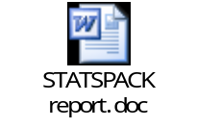

Purging Workload Statistics
Purging of Workload Statistics in Oracle 9i is manual and there are three options to clear old snaps.

- $ORACLE_HOME/rdbms/admin/sppurge.sql (will purge a range of snaps based on input)
- $ORACLE_HOME/rdbms/admin/sptrunc.sql (Will truncate all tables in Perfstat schema)
- $ORACLE_HOME/rdbms/admin/spdrop.sql (Will drop the user Perfstat including data)

Reference
http://download.oracle.com/docs/cd/B10500_01/server.920/a96533/statspac.htm#32843
http://www.dba-oracle.com/t_statspack_installation_steps.htm
http://dbaforums.org/oracle/index.php?showtopic=3091

